**Sprint 1 Plan - CSE 115 – Kondition**

**(April 9 - April 22, 2025)**

### Goal: Enable users to securely create accounts through a signup flow integrated with Firebase authentication, allowing them to log workouts.

### User Story 1

**As a user, I want to securely create an account so that I may log my workouts.**

* Implement signup UI flow (3 hours)
* Route Screens (2 hours)
* Handle Signup Errors and Feedback (2 hours)
* Design Account Creation UI (2 hours)
* Create key screens through Figma (4 hours)
* Implement Components for UI for account creation (3 hours)

**Total for user story 1: 16 hours**

**User Story 2**

**As a user, I want to log my workouts.**

* Draft Workout Form Schema in Code (2 hours)
* Add & Remove Exercise Rows Dynamically (2 hours)
* Hook “Save Workout” to Backend (3 hours)
* Validate All Form Fields Client-Side (2 hours)
* Implement UI for logging workouts (5 hours)

**Total for user story 2: 14 hours**

### Team Roles

### John Gmuender: Product Owner, Developer

* Shayna Das: Developer
* Kush Khanna: Developer
* Edward Zhou: Scrum Master
* Andy Vo: Developer
* Akash Srinivasan: Developer

### Initial Task Assignment

### John Gmuender: As a user, I want to securely create an account so that I may log my workouts, implement signup flow. As a user, I want to log my workouts, Draft Workout Form Schema in Code.

* Shayna Das: **As a user, I want to securely create an account so that I may log my workouts,** Route Screens, Create key screens through Figma. **As a user, I want to log my workouts,** Validate All Form Fields, Implement UI for logging workouts.
* Kush Khanna: **As a user, I want to securely create an account so that I may log my workouts,** Handle Signup Errors and Feedback. **As a user, I want to log my workouts,** Hook “Save Workout” to Backend.
* Edward Zhou: **As a user, I want to securely create an account so that I may log my workouts,** Design UI account creation. **As a user, I want to log my workouts,** Add & Remove Exercise Rows Dynamically.
* Andy Vo: **As a user, I want to securely create an account so that I may log my workouts,** Route Screens, Design Account Creation UI, Create key screens through Figma, Implement Components UI for account creation. **As a user, I want to log my workouts,** Implement UI for logging workouts
* Akash Srinivasan **As a user, I want to securely create an account so that I may log my workouts,** Design Account Creation UI. **As a user, I want to log my workouts,** Add & Remove Exercise Rows Dynamically.

### Initial Burnup Chart

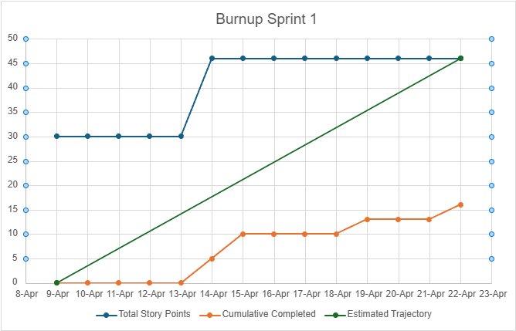

### Initial Scrum Board

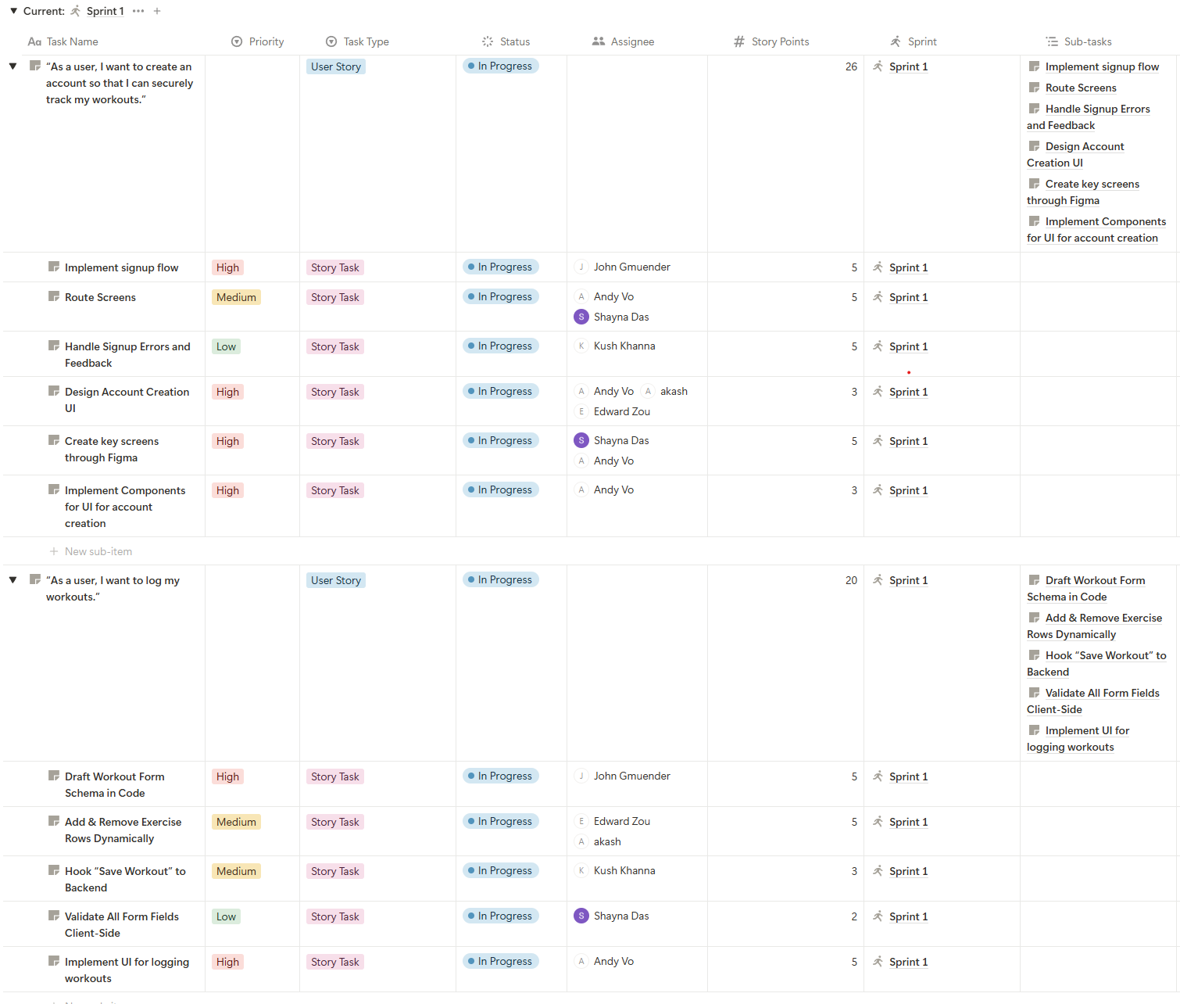

### Scrum Meeting Times

* Tuesday 10:00 - 10:30 AM (TA meeting)
* Wednesday 6:00 - 6:15 PM
* Friday 3:00 PM – 3:15 PM